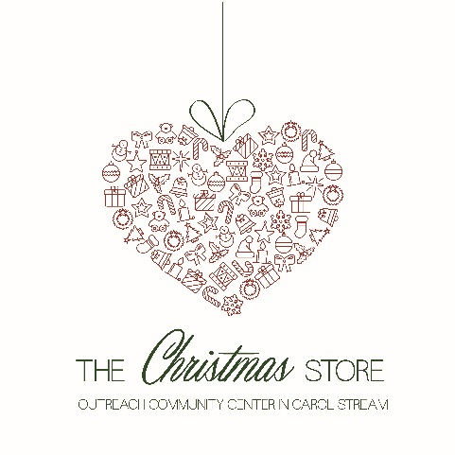
Gift List: Ages 0-5
- Gifts should be $15-25 in value
- Please choose toys that are nonviolent and age appropriate. Please, no Nerf guns.
- Books, stuffed animals & board games are not typically chosen by shoppers
- Toys featured at Costco, Sam's Club and Aldi are great options for gift selections

Boys
- Large Cars & TONKA Trucks
- Disney Character Toys
- Home Depot 18 Piece Toolbox
- Big Wheels
- 3-Wheel Toddler Scooters
- Paw Patrol

Girls
- Disney Princess Toddler Dolls
- Disney Frozen (Anything)
- Doc McStuffins (Anything)
- Dora the Explorer (Anything)
- Ethnic Baby Dolls- Ethnically
- Doll Furniture or Doll Strollers
- Tea Party Sets
- Play Dishes or Food Sets)

Sports
- Little Tikes Sports Set
- Indoor Basketball Hoops
- Tricycles
- Large Motor Games

Miscellaneous
- Walk and Ride Toys
- Train Play Sets
- Little People Sets
- Mega Blocks
- My Own Leaptop
- VTech Electronic Learning Toys
- Pretend Dress Up clothes
- Sleeping Bags
- LEGO Duplo Sets
- Art Easel & Chalkboard
- Educational Toys & Games
- Preschool Musical Instruments
- Play Hut Pop Up Tents
Check out our E-Gift Wish Lists
  - Shop from home!
Visit Amazon.com or Target.com and search their gift lists for “Outreach Center.”
Gifts may be sent directly to the Outreach Community Center in Carol Stream. Your purchase may qualify for free shipping! Please ship to arrive by November 30.

