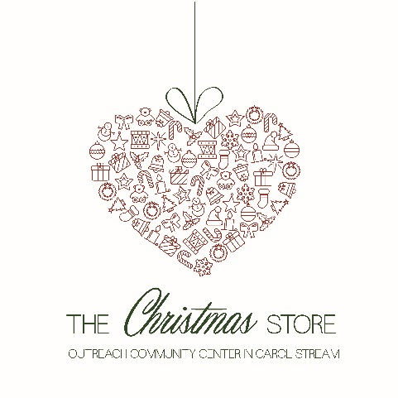
Gift List: Ages 6-11
- Gifts should be $15-25 in value
- Please choose toys that are nonviolent and age appropriate. Please, no Nerf guns.
- Books, stuffed animals & board games are not typically chosen by shoppers
- Please no Monster Ink or Bratz Dolss

Boys
- Super Hero Action Figures
- Star Wars (Toys & Apparel)
- Air Hogs RC Helicopter/Planes
- Remote Control Cars/Trucks/ATVs
- Bean Bag Chairs
- Small Tent or Sleeping Bags
- Minecraft (Toys & Apparel)
- LEGO Sets
- Hot Wheels Sets
Girls
- E.L.F. Deluxe Nail Polish Sets
- Disney Frozen
- Bean Bag Chairs
- Barbie Playsets
- Dolls – Ethnically Diverse (American Girl Style & Size)
- Sleeping Bag or small tents
- My Little Pony
Check out our E-Gift Wish Lists
  - Shop from home!
Visit Amazon.com or Target.com and search their gift lists for “Outreach Center.”
Gifts may be sent directly to the Outreach Community Center in Carol Stream. Your purchase may qualify for free shipping! Please ship to arrive by November 30.
Sports
- Razor Scooters
- Skateboards
- Bicycles w/ Helmet
- Track Skillz Pro Mini Hoop
- 4,5,6 Size Soccer Balls
- Sleds & Snowboards
- Basketballs

Crafts/Games
- Washi Tape Craft Set
- Jewelry Craft Set
- Creativity for Kids Craft Kits
- Crayola Craft Sets
- Gel Pen Sets (24+ count)

