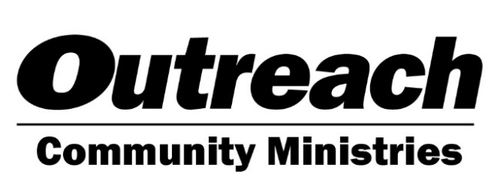

Restoring Hope, Providing Opportunities
373 S. Schmale, Ste 102, Carol Stream, IL 60188 (630) 682-1910
www.outreachcommunityministries.org

Electronic Funds Transfer (EFT) Authorization

I / We authorize Outreach Community Ministries to deduct funds from my/our checking/savings account as follows:

$___________ each month ($25 minimum per month) on the 15th day of the month,

OR

$___________ each quarter ($50 minimum per quarter) on the 15th day of September, December, March and June

This authorization will remain in effect until Outreach Community Ministries has received written notification that it is to be adjusted or cancelled

All Names on Account (please print): Signature(s):

______________________________________________ _____________________________________________

______________________________________________ _____________________________________________

Account Type: □ Checking □ Savings

Bank Name ____________________________________ Bank Phone __________________________________

Account Number________________________________ Routing/Transit Number ________________________
9-digit number printed on bottom left of check, deposit or withdrawal slip.

Please enclose a voided check or withdrawal slip with this form.

Contact Information:

Address ________________________________________________________________________________________________

City _____________________________________________ State_____________ Zip _____________________

Phone Number (Cell) _____________________________ Phone Number (Cell) ____________________________

Email _________________________________________ Email _________________________________________

Mail to: Outreach Community Ministries Scan and Email To: Sam Meinders, Database Manager
Attn: Sam Meinders, Database Manager smeinders@outreachcommin.org
373 S. Schmale Rd, Ste 102
Carol Stream, IL 60188

Your investment in the transforming programs at Outreach Community Ministries is most appreciated. Thank you!

